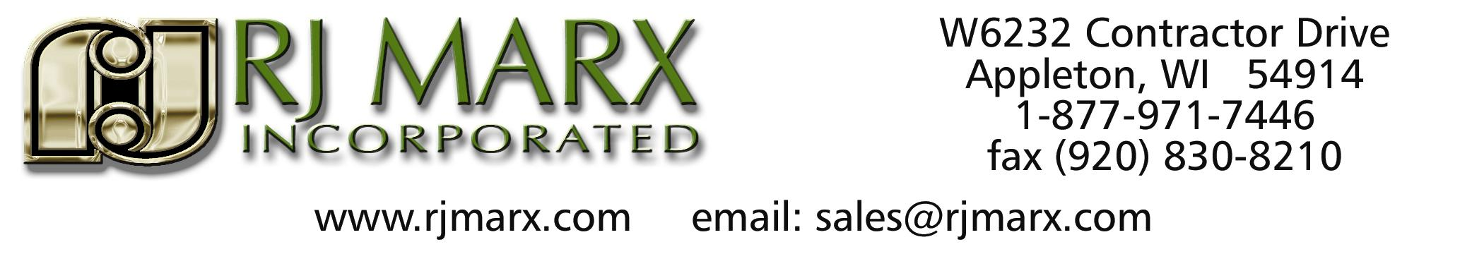

NEW DEALER INFORMATION FORM

CUSTOMER NAME: __________________________________________
TELEPHONE #_____________________FAX#_____________________
E-MAIL ADDRESS__________________WEBSITE_________________

CONTACT: ______________________EXTENSION #_______________
TELEPHONE #_____________________FAX#_____________________
E-MAIL ADDRESS____________________________________________

BILLING ADDRESS: __________________________________________
CITY___________________STATE______________ZIP CODE________

SHIPPING ADDRESS: __________________________________________
CITY___________________STATE______________ZIP CODE________

TYPE OF COMPANY:
SOLE PROPERITOR /PARTNERSHIP / CORPORATION
NUMBER OF YEARS IN BUSINESS OR DATE STARTED___________
FEDERAL ID #________________ OR SS#_________________________
RESELLERS PERMIT #___________

LIST OF OWNER/PARTNERS/ OR OFFICERS:
NAME: _____________________ADDRESS________________________
TITLE_______________________PHONE#_________________________

NAME: _____________________ADDRESS________________________
TITLE_______________________PHONE#_________________________

NAME: _____________________ADDRESS________________________
TITLE_______________________PHONE#_________________________

BANK NAME:_____________________CONTACT__________________
ADDRESS:_________________________PHONE#___________________
ACCOUNT #________________________TYPE : SAVINGS/CHECKING

LIST THREE (3) BUSINESS REFERENCES:

NAME OF BUSINESS: _________________________________________

CONTACT PERSON__________________PHONE#__________________
ADDRESS____________________________________________________
YEARLY SALES TRANSACTION AMOUNT_______________________
YEARS DOING BUSINESS WITH_______________________________

NAME OF BUSINESS: _________________________________________

CONTACT PERSON__________________PHONE#__________________
ADDRESS____________________________________________________
YEARLY SALES TRANSACTION AMOUNT_______________________
YEARS DOING BUSINESS WITH_______________________________

NAME OF BUSINESS: _________________________________________

CONTACT PERSON__________________PHONE#__________________
ADDRESS____________________________________________________
YEARLY SALES TRANSACTION AMOUNT_______________________
YEARS DOING BUSINESS WITH_______________________________

